Part 2 - Loading map data from Living Atlas to your project

# Step 1.

To get started on this click on the view tab on the top toolbar. Click on the Catalog pane. After that on the side bar will appear and here you can find the portal tab. Under this tab you will find many different items. Find the item Living Atas.

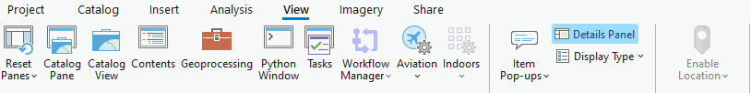

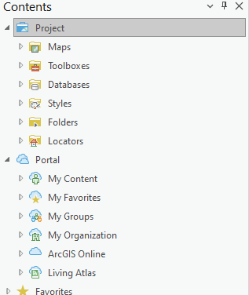

# Step 2.

Click on the living Atlas Tab

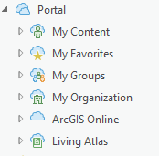

# Step 3.

Once you click on the Living Atlas Tab, you will find a search box and a filter. The filter lets you select any filters you need in order for you to find what kind of data you are looking for easier.

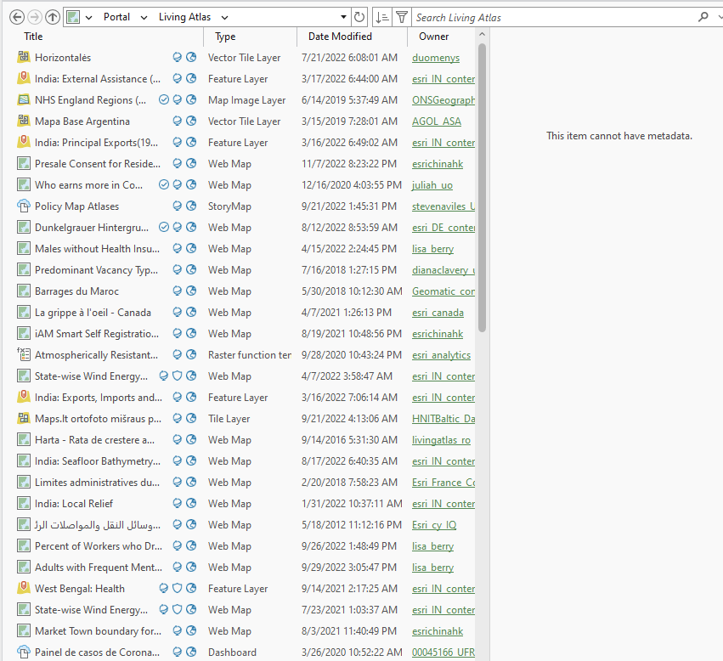

# Step 4.

When you click on the Living Atlas Tab you will also find a long list of possible map data that you can add to your project. The are all listed under a tab called Catalog

# Step 5.

Select any of the maps you want to add by right clicking on it and selecting add and open

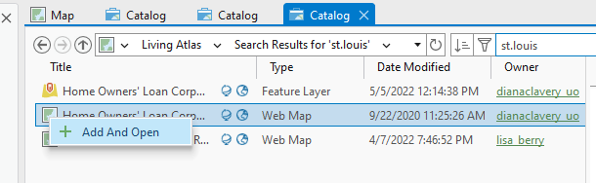

# Step 6.

Once you have done that the map that you selected will open up and you will be able to scroll through it.

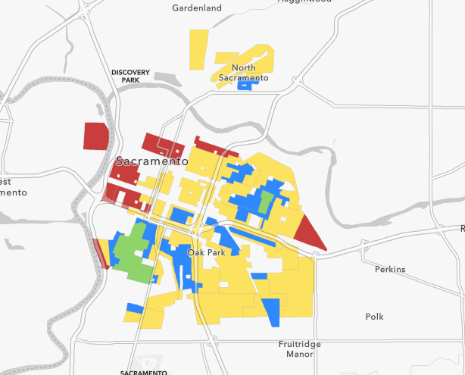

# Step 7.

Click through parts of the map and there will be a pop up that will show the data of a certain part of the map.

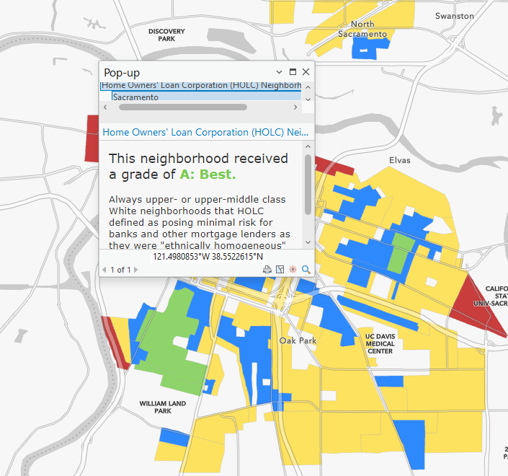

# Scavenger hunt:

Load up the map What percent of workers quit their jobs in August 2021 in the US in the same way as you were shown. Find the state with the highest quit rate.